

**OFFICE OF THE PRESIDENT**

**DATE :** June 8, 2020

**TO :** OPS and ANTF

**THROUGH :** The Deans, Directors, Principals, and Office Heads

**SUBJECT : Adjustment of Lunch Break to 12:00 noon to 1:00 p.m. and**  **Dismissal to 4:30 p.m.**

In line with the University’s implementation of a skeletal workforce for the non-teaching personnel (OPS and ANTF), please be advised that the lunch break shall be adjusted to 12:00 noon- 1:00 p.m. instead of 12:00 noon to 2:00 p.m. and the dismissal time from 5:30 p.m. to 4:30 p.m. The arrangement shall take effect from June 8, 2020 to June 15, 2020.

Thank you for your attention and cooperation.

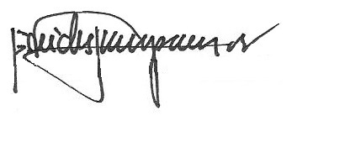

REV. FR. CRISTOPHER C. MASPARA, OAR

University President